

General Information Sheet

2011 IAU 50KM WORLD TROPHY FINAL

ASSEN
THE NETHERLANDS
20th of AUGUST, 2011



GENERAL INFORMATION SHEET

2011 IAU 50KM WORLD TROPHY FINAL

ASSEN, THE NETHERLANDS

SATURDAY 20th of AUGUST 2011

TABLE OF CONTENTS

- WELCOME
- NATIONAL ATHLETICS FEDERATION
- LOCAL ORGANISING COMMITTEE
- IAU
- GENERAL COMPETITION INFORMATION
- ENTRIES
- TRAVEL INFORMATION & TRANSPORT PLAN
- ACCOMMODATION
- TECHNICAL MEETING
- PAYMENT OF TRAVEL GRANTS
- OPENING CEREMONY
- CLOSING CEREMONY
- PRIZES
- WEATHER CONDITIONS
- GEBERAL TIME SCHEDULE
- VISA INFORMATION

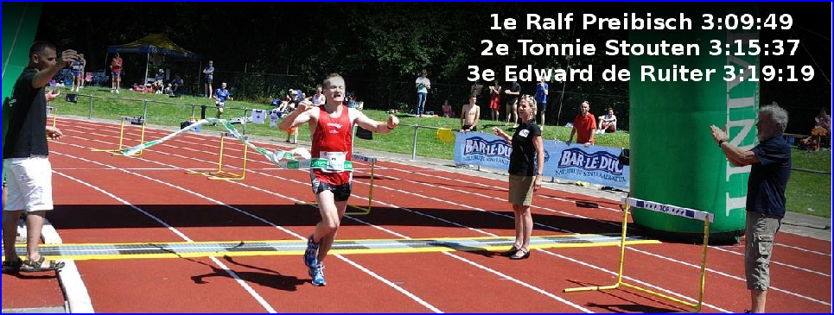

Results of the 50K run in July 2010.

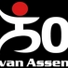

- WELCOME

The local Organizing Committee (LOC) is honoured to organize the 2011 50 KM World Trophy Final in Assen (The Netherlands). We welcome all athletes and coaches in Assen.

Assen is a municipality and a city in the north eastern Netherlands, capital of the province of Drenthe. It is situated in attractive surroundings. It is not for no reason that the town describes itself as "Assen - a town among the trees". Assen lies encircled by picturesque villages, with a number of nature parks only a stone's throw away.
In Assen, nature is literary around the corner; an extended network of excellent walking and cycling paths takes you into the woods and the hills in and around the city. Assen has a wide variety of art, culture and leisure clubs. More than one hundred sports clubs with excellent accommodations welcome you. You can ice-skate, swim in a tropical swimming pool or run at a great athletics track. Every year on the last Saturday in June, the spectacular TT races are held in Assen.

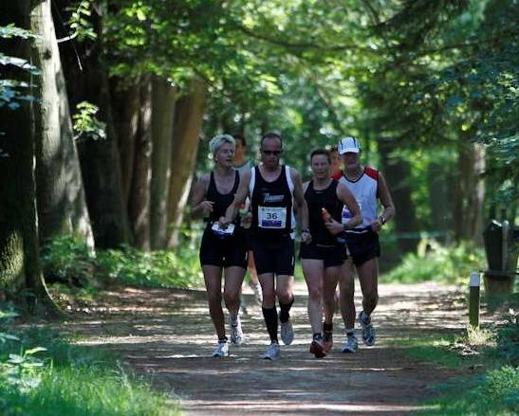
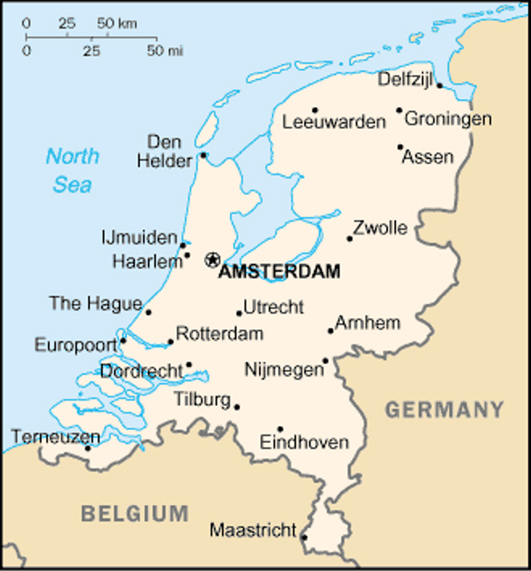

- NATIONAL ATHLETICS FEDERATION

NAME: Atletiekunie
ADDRESS: Papendallaan 60, 6816 VD ARNHEM
COUNTRY: THE NETHERLANDS

TEL: 0031 (026) 483 48 00
FAX: 0031 (026) 483 48 01
E-MAIL: info@atletiekunie.nl
WEBSITE: http://atletiek.nl/

- LOCAL ORGANISING COMMITTEE (LOC)

NAME OF THE IAAF MEMBER FEDERATION
NAME: AAC’61
ADDRESS: Achterpad 1
9405 BN Assen
The Netherlands
WEBSITE: http://www.aac61.nl/

CONTACT DETAILS
NAME: ASSEN 50
WEBSITE: http://www.de50vanassen.nl/
E-MAIL: de50vanassen@home.nl

TWITTER: follow@De50vanAssen

TEAM RACE DIRECTOR 50KM
NAME: Nellie van der Made
TEL: 06 53386867
E-MAIL: Mica.made@planet.nl

DIRECTOR OF COMMUNICATIONS
NAME: Erik Kemp
TEL: +31 (0)6 651083771
E-MAIL: Erik.kemp@planet.nl

SECRETARY
NAME: Frank Zondag
E-MAIL: de50vanassen@home.nl

- INTERNATIONAL ASSOCIATION OF ULTRA RUNNERS

Website: http://www.iau-ultramarathon.org/

IAU GENERAL SECRETARY
NAME: Hilary Walker (GBR)
TEL: +44 75895342 (home) +44 72105884 (office)
MOB: +44 7884473336
E-MAIL: hilary.walker@iau-ultramarathon.org
SKYPE: hilary-walker

DIRECTOR OF ORGANISATION & TRAVEL GRANT INFORMATION
NAME: Jan Vandendriessche (BE)
TEL: +32 59276043
MOB: +32 495267884
E-MAIL: jan.vandendriessche@iau-ultramarathon.org
SKYPE : jan_vandendriessche

DIRECTOR OF COMPETITIONS
NAME: Liesbeth Jansen (NL)
TEL: +31 597432972
MOB: +31 622490053
E-MAIL: liesbeth.jansen@iau-ultramarathon.org
SKYPE: liesbeth_jansen

DIRECTOR OF PROTOCOL
NAME: Roger Bonnifait
TEL: +33 607432671
E-MAIL: roger.bonnifait@iau-ultramarathon.org

DIRECTOR OF COMMUNICATIONS
NAME: Nadeem Khan (Can)
TEL: +1 716 3926657
E-MAIL: nadeem.khan@iau-ultramathon.org

EUROPEAN REPRESENTATIVE
NAME: Stefano Scevaroli (IT)
E-MAIL: stefano.scevaroli@iau-ultramarathon.org

- GENERAL COMPETITION INFORMATION

MIAUC: IAU 50 KM WORLD TROPHY FINAL
DATE: 20 August 2011
START TIME: 10.00 CET
MAX. TIME: 6 hours

COURSE: Race 10 laps of 5K. The track is located in a forest and free of traffic, the average width of course track 3.5 meters.
Pavement (80%)

ELEVATION: 0

COMPETITION: MEN’S INDIVIDUAL COMPETITION & WOMEN’S INDIVIDUAL COMPETION

OPEN RACE: The expected number of participants is 250.

COURSE RECORD: Male course record is 3.09.49 and female 3.58.43. The track has been slightly adjusted for 2011 and is expected to be faster than the previous years.

Course map (see also attachment 1)

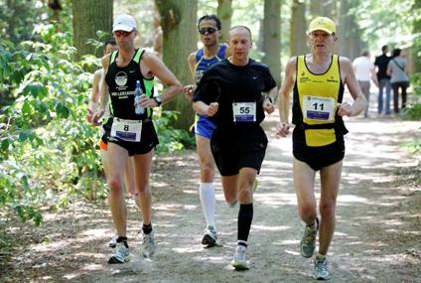
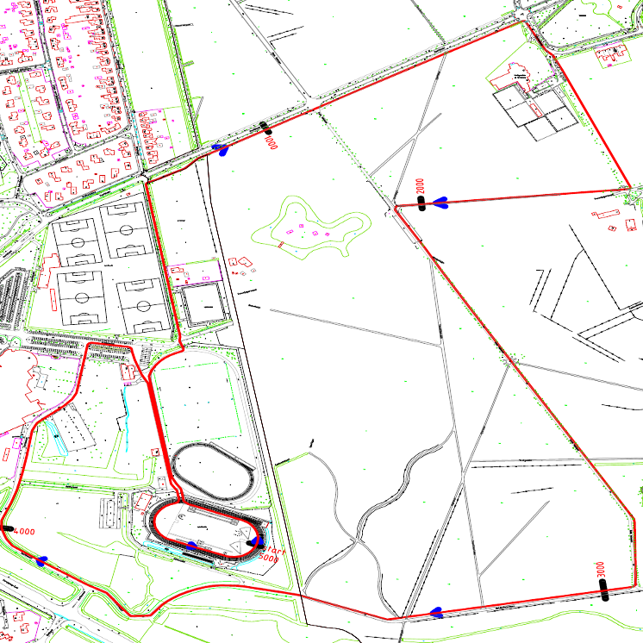

- ENTRIES

The IAU will invite 40 athletes (20 men and 20 women) to participate in the 50KM World Trophy Final. The invitations will be based on the results of Selection Races operated in the months prior to the final race.

All 40 athletes will be contacted directly or indirectly by the IAU. The IAU will collect the personal details for athletes and send this to the LOC

The series of qualifying races, on six continents, are:

1 | 28/08/2010 | IRL | Galway
2 | 10/09/2010 | NED | Winschoten
3 | 23/01/2011 | GBR | Gloucester
4 | 29/01/2011 | GER | Rodgau
5 | 6/03/2011 | USA | Caumsett
6 | 19/03/2011 | RSA | Om die Dam
7 | 3/04/2011 | ITA | Di Seregno della Brianza
8 | 10/04/2011 | AUS | Canberra
9 | 16/04/2011 | ZWE | Tibro
10 | 17/04/2011 | FRA | Belves
11 | 17/04/2011 | RSA | Loskop Marahton
12 | 25/04/2011 | ITA | Di Romagna
13 | 7/05/2011 | CAN | Fast trax
14 | 26/06/2011 | GBR | Bodington
15 | 26/06/2011 | ITA | Pistoia-Abetona
16 | 26/06/2011 | JPN | Lake Saroma
17 | 10/07/2011 | LAT | Daugavpils

All other athletes who participate in the final race of the IAU 50KM Trophy Final must be affiliates to their National Athletics Federation, e.g. be members of an athletic club, and must present a document of proof that they are members. Only then they can be ranked in the results of this Final race. Non-affiliated athletes will only count in the open race.

- TRAVEL INFORMATION AND TRANSPORT PLAN

HOW TO TRAVEL TO ASSEN
Schiphol
Schiphol (railway) station is situated directly below the airport. You can pick up a free baggage trolley from the platform. Via Schiphol Plaza, you can walk straight to the Railway station.
Assen is directly connected to the Groningen-Zwolle (National Rail: NS) rail line. There is a connection in both directions twice every hour.
Train tickets
Train tickets for domestic travel are available from the yellow ticket machines near the platforms at Schiphol Plaza. Tickets (for domestic and international travel) are also available from the ticket offices, which are situated close to the red/white-checked cube at Schiphol Plaza. Staff at the ticket offices will also be able to provide you with train departure information.
Information about your train journey
The journey planner on the NS website will provide you with information on the fastest and shortest route between your home address and Schiphol. It also contains the latest travel information, including details of temporary timetable changes.
http://www.ns.nl/en/

AIR
Amsterdam Schiphol Airport (AMS) is the major airport in The Netherlands. It is located in the western part of The Netherlands.

PUBLIC TRANSPORT CONNECTIONS FROM SCHIPHOL AIRPORT TO ASSEN
The most convenient way to travel to Assen is by railway (NS). There is a regular train service (NS) from Schiphol Airport (between 08.00 and 23.00 2 trains every hour; xx.19 and xx.49 track 3). The trip from Schiphol to Assen requires approximate 2 hours and 15 minutes. Taxis are available at the Assen trainstation travel to the accommodation. Travel time about 5 minutes.

CAR RENTAL
Most major car hire companies operate from Schiphol Airport

GENERAL ADVICE/PICK-UPS
On request the LOC can assist you with transportation options and pick-ups (from Assen train station) as appropriate.

The LOC will arrange transport to your accommodation if you notify the LOC of your expected arrival time at the Assen train station. Please contact: +31 (0)6-12243581 (from 12 August onwards) or via e-mail: de50vanassen@home.nl.

- ACCOMODATION

Invited athletes will be accommodated in Hotel De Bonte Wever. De Bonte Wever**** hotel is located in Assen, close to the ‘Asserbos’ wood and the city centre. The hotel offers modern and well-furnished guestrooms, all equipped with air conditioning, flat-screen TV, free internet access. The rooms furnished with single beds, a seating area and a modern bathroom.
In the hotel’s buffet restaurant breakfast, lunch- and dinerbuffet with wide variety are served.
The LOC offers:

Half board accommodation (breakfast and dinner (incl. 3 drinks), free of charge, for all invited male and female athletes as follows:
- 3 nights for those who are within 4 hours flying time from their capital city to the Netherlands;
- 4 nights for those who must fly at least 4 hours but less than 9 hours to the Netherlands;
- 5 nights for those who must fly a minimum of 9 hours from their capital city to the Netherlands.
- The athletes have free access to the swimming pool, the sauna and the fitness centre.

The rooms will be shared between 3 or 4 athletes. Upgrading to a single room is possible for the personal account of the athlete. Price indication: upgrade to single room for 3 nights half board 133.50 Euro’s (additional cost to be paid by the athlete). Upgrading needs to be arrange by the athlete him/herself with the hotel.

Athletes will be accommodated in the hotel, which will be assigned once all entries are confirmed.

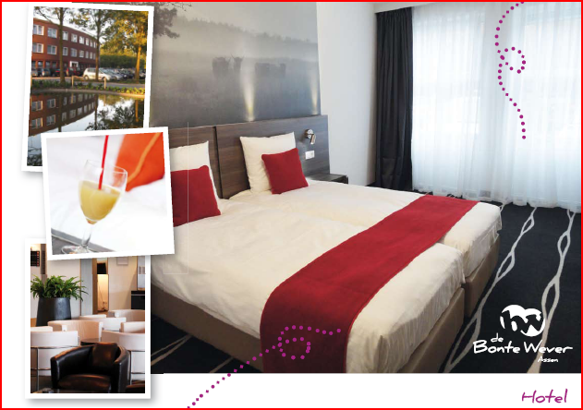

De Bonte Wever Assen
Stadsbroek 17
9405 BK Assen
Tel: +31 (0)592 - 356000
Fax: +31 (0)592 – 303715
Internet: http://www.debontewever.nl/
E-mail : info@debontewever.nl

- TECHNICAL MEETING

PLACE: AAC’61 Accommodation
ADDRESS: Achterpad 1, Assen
DAY: Friday 19 August
TIME: 18.30 – 19.30 CET

All runners will receive, on the day of arrival, a brochure with all the technical guidelines/rules specific for this MIAUC

- PAYMENT OF TRAVEL GRANTS

The payment of Travel Grants is scheduled right after the TECHNICAL MEETING, see details under point 9 (above).

- OPENING CEREMONY

PLACE: Assen City Centre (Koopmansplein)
DAY Friday 19/8/2011
TIME: 17.00 CET

- CLOSING CEREMONY & AWARDS

The awards will be presented on Saturday 20 August 2010 at 16.00 CET
PLACE: ACC’61 accommodation, Achterpad 1 Assen.

- PRICES

The first three male and female athletes will receive medals awarded by the IAU. There are no cash prizes available.

- WEATHER CONDITIONS

Average day temperature in Assen in August 23 Celsius

- GENERAL TIME SCHEDULE

Please note: this time table may be subject to small revisions or additions. All athletes will be notified if any are made.

WEDNESDAY/THURSDAY/FRIDAY 17/18/19 AUGUST: Arrival of athletes

FRIDAY (19/8) 13.00 – 14.00 Provinciehuis: Press Conference (tbc)
14.30 – 17.00 Historic sightseeing tour in Assen area for athletes
invited by the IAU and guests invited by LOC.
17.00 – 18.00 Openings ceremony in city centre of Assen
18.00 – 19.00 Technical Meeting: AAC’ 61 accommodation
20.00 Dinner

SATURDAY (20/8) 10.00 Start Race
16.00 Price ceremony / Closing Ceremony AAC’61

SUNDAY (21/8) Departure of the athletes.

- VISA INFORMATION
Citizens of certain countries require an entry visa for The Netherlands.

If you are a citizen of a country that is on the schedule below, you do NOT require an entry visa for The Netherlands. Citizens of countries which are not on the list MUST apply for a visa before they travel to The Netherlands.

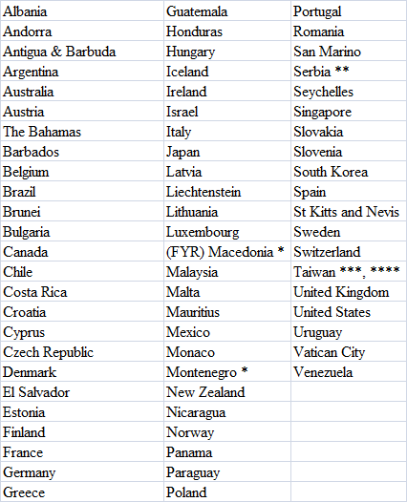
* The visa exemption applies only to holders of biometric passports.
** Except for holders of a Serbian passport issued by the Serbian Coordination Directorate(Koordinaciona uprava).
*** The exemption from the visa requirement applies only to holders of passports issued by Taiwan which include an identity card number
**** Concerns territorial entity and authority that is not recognized as a state by at least 1 (EU-)member state
DATED 14/2/2011.

For visa information and/or details of Dutch Embassies please see the Government website below or contact the Department of Foreign Affairs.
http://www.minbuza.nl/en/Services/Consular_Services/Visa/Visas_for_the_Netherlands_Schengen_Visas

Applying for a Schengen visa
Procedure for applying for a visa at a Dutch embassy or consulate-general.









