
General Information Sheet

for the organisation of the

IAU Asian Championships 100K 2011

JEJU (KOR)

March 26th 2011

vs091115

GENERAL INFORMATION SHEET

Table of Contents

- WELCOME

- LOC

- IAU

- General competition information

- PEF’s & FEF’s

- VISA

- Transportation Plan

- TRAVEL GRANTS

- Accommodation

- meals

- TECHNICAL MEETING

- OPENING CEREMONY

- awards CEREMONY

- WEATHER CONDITIONS

- GENERAL TIME SCHEDULE of this MIAUC

- WELCOME

Located on the southwest seas off the Korean peninsula, Jeju Island is Korea's largest island. It has a distance of 450km from Seoul, 300km from Busan, 1580km from Tokyo in Japan, 490km from Shanghai in China and 1700km from Hong Kong.
It takes a maximum of 1 hour to fly from Korean mainland airports to Jeju with planes leaving from Gimpo Airport in Seoul. From the major departure destinations, 94% of travelers come to Jeju Island by plane. Jeju international airport has 12 local and 6 international direct airlines, which links major cities with 130 aircrafts. There are 6 flights to Tokyo, 4 flights to Osaka, 2 flights to Beijing and 3 flights a week to Hong Kong. Check for flight information in advance, for there may be seasonal changes in the schedule.
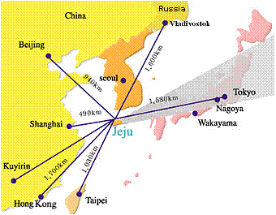
Jeju Island is a favorite holiday and honeymoon destination for Asian travelers. The island has a special beauty that is similar to the Hawaiian Islands in many ways. The island's scenic beauty and opportunities for outdoor activities are starting to attract adventure travelers from all over the world. Some of the most popular activities are cycling, hiking and ultramarathon.

The Jeju International Ultra Race was organised for the first time in 2002. The event initially started as a Jeju 200km Road which runs around the Island and the Mt. Halla 148km trail later. The Jeju International Ultra Race became such a successful event because of a beautiful course. With a pride of good organisation so far, Korea invites your national athletes to the 2nd edition of the IAU 100km Asian Challenge, Jeju on March 27, 2010.

- Local organizing Committee (LOC)

Federation | KUMF (Korea Ultra Marathon Federation)
Website | www.kumf.org
PRESIDENT

Name | Mr Changsoun Jeong
Mobile | +82.16.259.4380
E-mail | J001199@naver.com
RACE DIRECTOR

Name | Mr Sangdon Seo
Mobile | +82.10.7747.9257
E-mail | sdseo3313@yahoo.co.kr
COODINATOR

Name | Mr Bokjin Park
Mobile | +82.1o.3727.8541
E-mail | faab52@hanmail.net
- International Association of Ultrarunners (IAU)

Website www.iau-ultramarathon.org

PRESIDENT

Name | Dirk Strumane
Mobile | +32 495 26 69 52
E-mail | dirk.strumane@iau-ultramarathon.org
SECRETARY

Name | Hilary Walker
Tel. | +44 7589 5342 (home) +44 7210 5884 (office)
E-mail | secretary@iau-ultramarathon.org

- GENERAL COMPETITION information

MIAUC | IAU 100KM ASIAN CHAMPIONSHIP
Date | Saturday March 26 2011
Start time | 08:00
Max. time | 15 hrs
Course | Road
Short description of the course:
A very flat course with its scenic sea views around the Jeju island. Starting at Tapdong Beach Stage in Jeju City, the runners go west, pass along the edges of the island counterclockwise and finish in front of the Jeju World Cup Stadium in Seogwipo City. The refreshment zone is located at every 5km and serves personal drinks, water, candy, fruit and something to eat.

Drop-off bag | Personal belongs including clothing and shoes to change into something more comfortable after a shower at finish area, should be collected 04:00-05:00 on March 26.

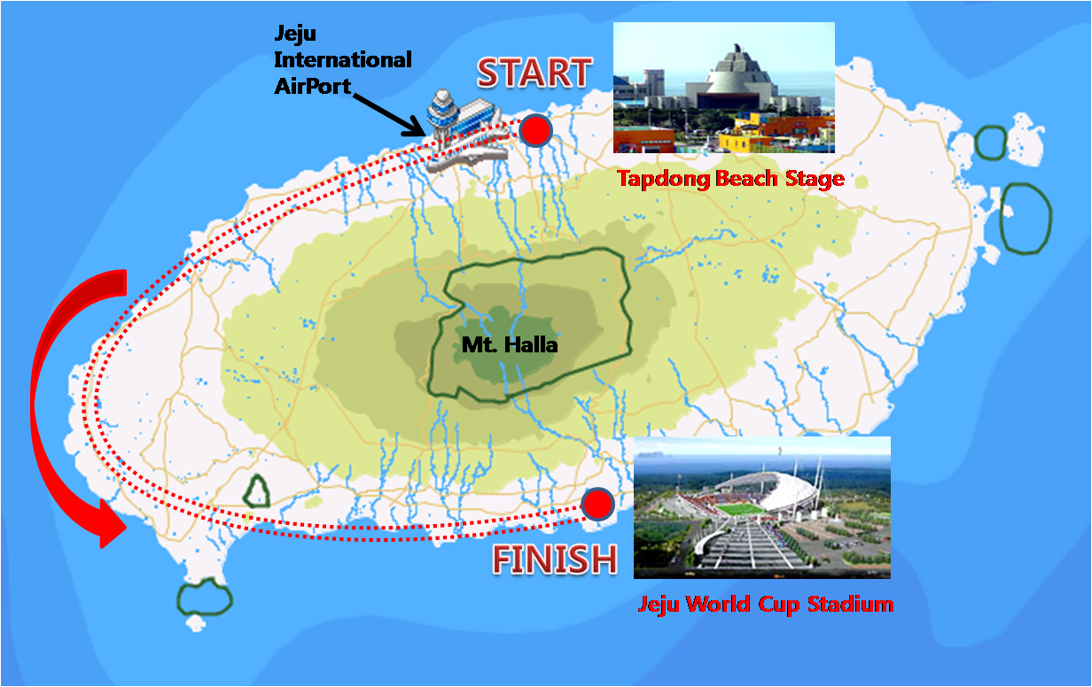

Competition | Men’s individual competition  Women’s individual competition
 | Only athletes entered by their National Federation in Asia can compete in this MIAUC. Every Country can send 3 men and 3 women who can compete in this MIAUC.
Open race | Yes
 | Any international runner who doesn’t belong to MIAUC competitor above can take part in the open race and the participation fee is free of charge.
 | Limited runners: No
Other races | Jeju 200km
 | Same course : Yes,
 | Same starting time : Yes
 | Limited runners : No
Mt. Halla 148km

Same course : No
Same starting time : Yes
Limited runners : No

50km Race
Not applicable this year

- Final information (FEF) Forms

The FEFs should be completed and sent, before the DEADLINE time.
With the FEFs, each Federation will send the list of its own runners, with names, date of births, sex and curriculum vitae or personal bests and will inform the LOC about the procedure and the timetables of arrival and departure.
DEADLINE FEF’s : February 15th 2011
All forms must be send in digital format to:

LOC | Name : | Bokjin Park
 | E-mail : | faab52@hanmail.net
IAU | Name : | Hilary Walker
 | E-mail : | secretary@iau-ultramarathon.org
Final entry form
With the final entry form, each Federation will send the final list with the names of their athletes, dates of birth, sex and curriculum vitae or personal bests and will inform the LOC about the travel itinerary details of the delegation members (arrival and departure times, flight numbers, required number of rooms, required number of nights, required number of meals to be provided)
Please note that the travel and accommodation offers made by the LOC are conditional on the prompt return of the entry forms bythe deadlines.

- VISA

Any foreign visitor wishing to visit Korea should have a valid passport
IAU Asian Members which don’t need a visa prior to departure: Japan, Taiwan
IAU Asian Members which do need a visa prior to departure but have a Korean Embassy in their country : Philippines, Nepal
IAU Asian Members which do need a visa prior to departure but don’t have a Korean Embassy in their country: none

- Transportation plan to the athletes village (av)

Airport | Name | Jeju International Airport
 | Place | Jeju City
 | Distance to AV | 5km
The LOC will put up a “welcome helpdesk” in the airport during the arrival times of the delegations.
Shuttle Bus | From airport to AV | Yes
 | Expenses round ticket | free

- TRAVELGRANTS

The Organizing Committee will offer US$1,000 travel grant to each IAU Asian Member
Federation(AMF) or AMF-to-be who will join the IAU membership by February 28th, 2011.
The travel grant should be given according to ‘per federation’, not by ‘the number of
athletes’. The payment is scheduled right after the Technical Meeting.

- ACCOMMODATION

The Organizing Committee will offer full board accommodation, free of charge,
for a maximum of 3 male and 3 female athletes per delegation and
an international athlete, whose country belongs to the IAU’s member,
participating in the 100km open race,
for a maximum of 3 nights for delegations.
In principle, athletes will share a room.
The accommodation is available for the additional nights with no extra cost, subject to
An agreement from LOC

ATHLETES VILLAGE (AV)

Name  Website | Jeju Myungdoam Youth Hostel  www.myungdoam.or.kr  Located in Tap-dong in downtown in Jeju City, it provides the best convenience for the athletes. Very near to the start place, Tapdong Beach Stage, 15 minutes by foot/ shuttle bus.

- meals

The Organising Committee will offer the designated meals and pasta (see below), free of charge, for a maximum of 3 male and 3 female athletes per delegation and an international athlete whose country belongs to the IAU’s member, participating the 100km open race. Additional athletes or supporters should pay KRW5,000.- for each (extra or additional) meal
But free for pasta party (meal and pasta ticket available on arrival).

In general:
Breakfast at 07:00 – 09:00. On the race day 04:00-05:00
Lunch at 12:00-13:30
Dinner at 18:00-20:00

The pasta party starts at 19:00, right after the Opening Ceremony.

- TECHNICAL MEETING

Place | Meeting Room, AV
Day | Friday March 25
Time | 16:00
 | The most specific details can be found in the IAU blueprint for the Technical Meeting manual.

- OPENING CEREMONY

Place | Hall, AV
Day | Friday March 25
Time | 18:00

- AWARDS CEREMONY

Place | Jeju World Cup Stadium (= finish place)
Day | Saturday March 27
Time | 14:00

IAU 100km Asian Championship (men & women)

1st Place – IAU Gold Medal + US$700.-
2nd Place – IAU Silver Medal + US$500.-
3rd Place – IAU Bronze Medal + US$300.-

IAU New Record US$2,000.-

- WEATHER CONDITIONS

Seasonally, summer climate is temperately hot and winter climate is warmest in Korea and therefore, the annual difference of temperatures is very small. The oceanic climates of Jeju Island influence temperature changes as well as the volume of rainfall. It is because Jeju is an island surrounded by seas and Mt. Halla rises in its center. The average weather conditions on the race day in the past 5 years:

Max. Temperature | 17
Min. Temperature | 10
Humidity | 60%

- GENERAL time schedule of this miauc

Thursday, March 24 Arrival of the national teams
Friday, March 25 16:00 Technical meeting
18:00 Opening Ceremony
19:00 Pasta Party
Saturday, March 26 04:00 till 05:00 Collection of the personal belongings &
special drinks
08:00 Start of the IAU 100km AC
15:30 arrival of the first athlete of 100km
18:00 Awards Ceremony
Sunday, March 27 Departure of the national teams
Free one day sightseeing for those who want before departure

